**DAILY ONLINE ACTIVITIES SUMMARY**

|  |  |  |  |  |  |  |  |  |
| --- | --- | --- | --- | --- | --- | --- | --- | --- |
| **Date:** | **05/05/2020** | | | | | **Name:** | **PONICA.J** | |
| **Sem & Sec** | **4TH & B** | | | | | **USN:** | **4AL18CS055** | |
| **Online Test Summary** | | | | | | | | |
| **Subject** | | **-** | | | | | | |
| **Max. Marks** | | **-** | | **Score** | | | **-** | |
| **Certification Course Summary** | | | | | | | | |
| **Course** | **FIREBASE ML KIT FOR ANDROID DEVELOPERS** | | | | | | | |
| **Certificate Provider** | | | **UDEMY** | | **Duration** | | | **5HOURS** |
| **Coding Challenges** | | | | | | | | |
| **Problem Statement:** Write a Java Program to find the duplicate characters in a string | | | | | | | | |
| **Status:EXECUTED** | | | | | | | | |
| **Uploaded the report in Github** | | | | | **YES** | | | |
| **If yes Repository name** | | | | | **https://github.com/ponica-jaya/LOCKDOWN-CODING.git** | | | |
| **Uploaded the report in slack** | | | | | **YES** | | | |

Online Test Details: (Attach the snapshot and briefly write the report for the same)

TODAY 5TH JUNE WE HAD TEST ON OS BUT MAM POSTPONDED THE EXAM.

Certification Course Details: (Attach the snapshot and briefly write the report for the same)

**Firebase** Helps You Build, Improve, & Grow Your Mobile Apps. Check It Out Today! For Mobile or Web Apps. Build Extraordinary Apps. Build Fast For Any Device.

HENCE MY TOPIC IS FIREBASE ML KIT FOR ANDROID USERS WHICH I HAD ENROLLED IN UDEMY.

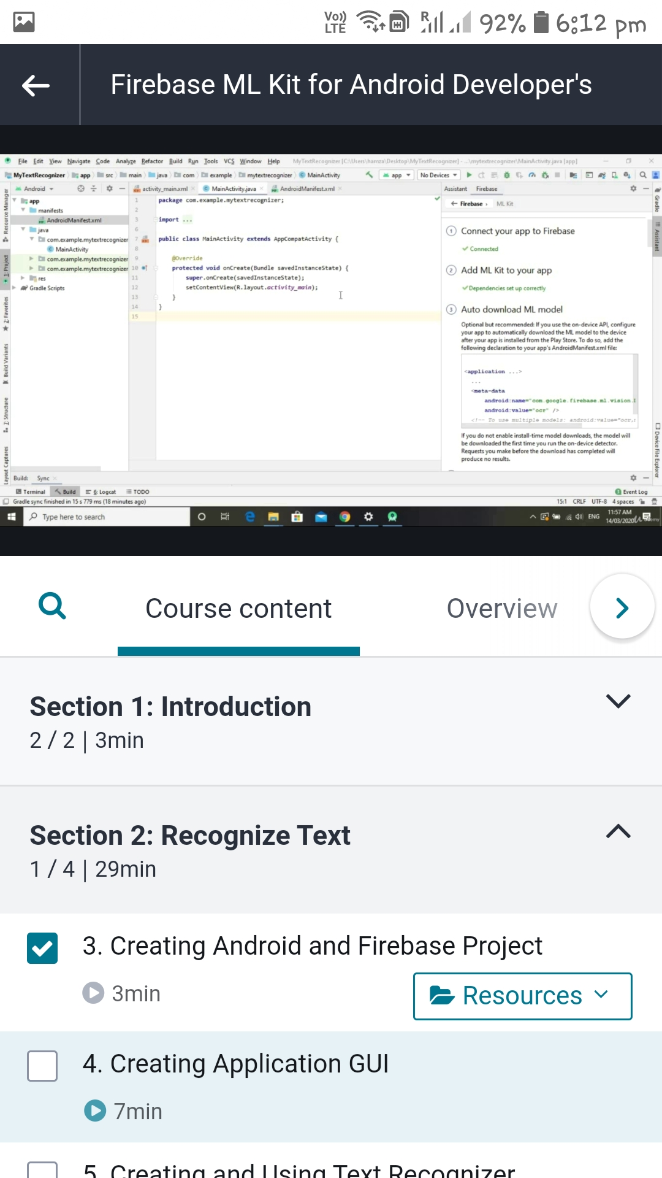

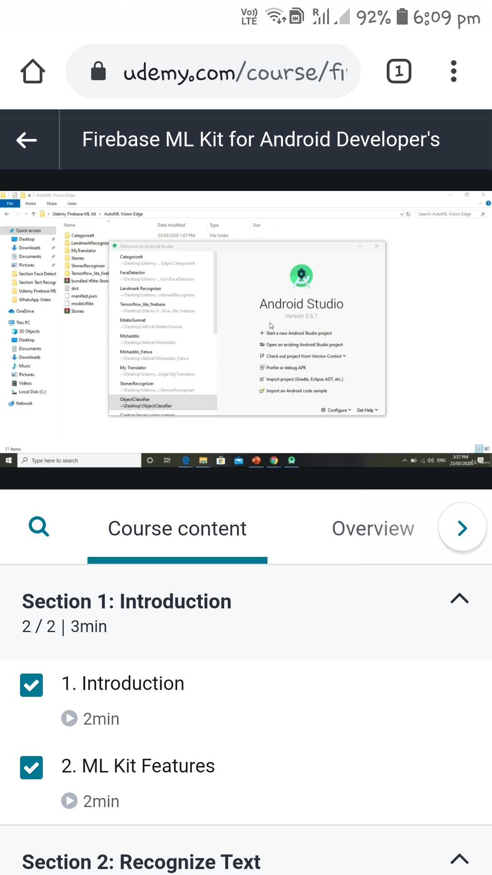

Coding Challenges Details: (Attach the snapshot and briefly write the report for the same)

Write a Java Program to find the duplicate characters in a string

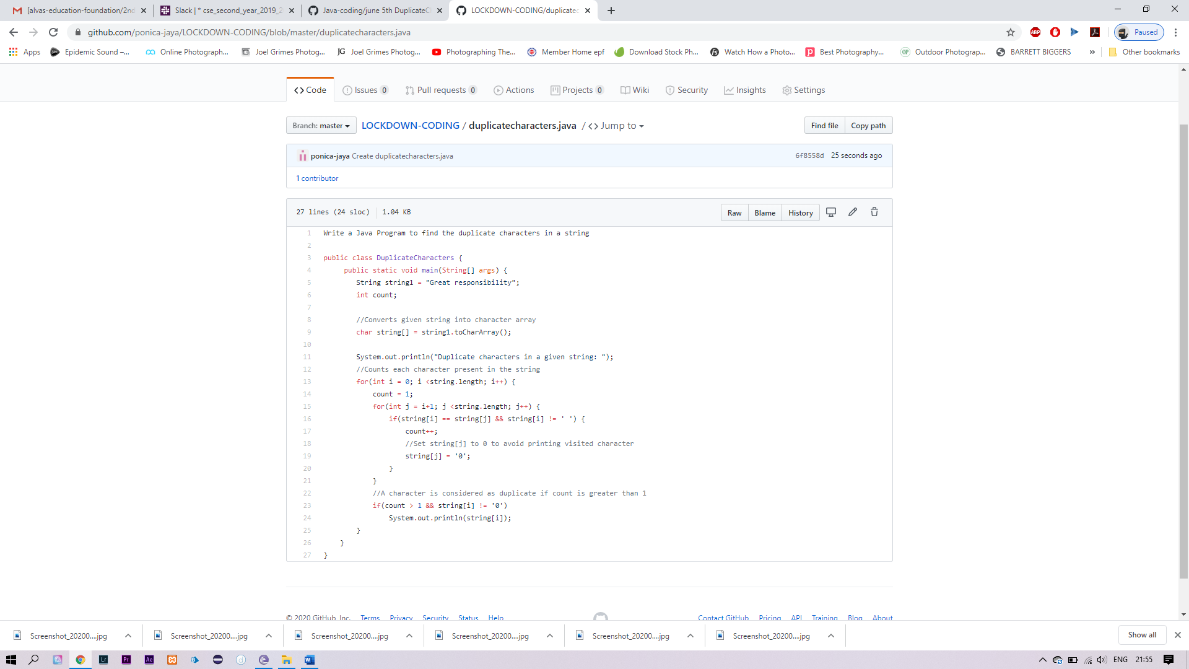

SOLUTION IS UPLOADED IN MY GITHUB REPOSITORY